PAPER TITLE
Times New Roman 12, Bold, Centered

A. Author^{1*}, B. Author², and C. Author¹
(Times New Roman 12, centered)

¹Department of Physics, University of Latvia,
3 Jelgavas street, LV-1002 Riga, Latvia
²Faculty of Chemistry, Riga Technical University,
8 Paula Valdena street, LV-2169 Riga, Latvia
*Corresponding author’s e-mail: aauthor@lu.lv

Key words: up to 5 keywords

Abstract (Up to 200 words)

Place your text here. Please use Time New Roman 12 pt, justified. Line spacing 1,0.
You can use italics, bold, underlines, superscripts and subscripts.
Abstracts should not exceed two pages (A4 size). Use numbered references in brackets [1-4].
A short introduction and motivation of the research should be given. The considered problem and performed study should be concisely described, and the obtained results and conclusions should be given.

Introduction (titles and structure can be different )

1. Numbered figures and captions should be centered.

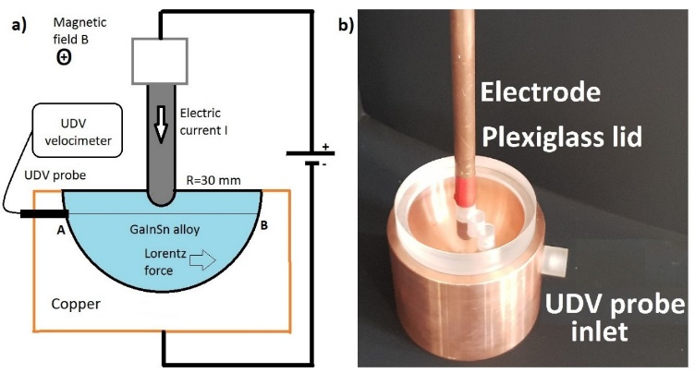

Figure 1: Experimental setup; a) principal scheme of the experiment; b) copper container and electrode used in model experiments.
(Times New Roman, 11 pt)

Results and discussion

2. Equations should be numbered and centered; notations explained if needed.

, (1)

, (2)
where A stands for …, j is …. , etc.

3. Tables should have numbers and titles and should be centered.

Table 1: Comparison of characteristic dimensionless numbers
(Times New Roman, 11 pt)

Dimensionless number | GaInSn model | Welding | Physical explanation
$$Re$$ | 3300 | 3700 | Turbulent flow if Re>2000
$$Ha$$ | 120 | 10 | Electromagnetic/viscous
R_{m} | 0.006 | 0.005 | Advection/Diffusion

Conclusions

Acknowledgements. If needed!

References (Times New Roman, 11 pt)

- K.C. MILLS, B.J. KEENE, R.F. BROOKS and A. SHIRALI. Marangoni effects in welding. Phil. Trans. R. Soc. Lond., vol. 356 (1998), no. 3, pp. 25-34.
- V. BOJAREVICS, J. FRIBERGS, E.I. SHILOVA, E.V. SHCHERBININ. Electrically Induced Vortical Flows. (Kluwer Academic Publishers, Dordrecht, Boston, London, 1989).
- Yu. GELFGAT, S.M. GUREVICH, Ya. KOMPAN, E. MIKELSONS, K. NOVIKOV. Effect of magnetic field on the structure of welded joints in electrical slag welding of titanium alloys. Magnetohydrodynamics, vol. 2 (1973), no. 2, pp. 155-157.

