I prefer to report this work at the EPM 2021conference as

Poster
Oral presentation

EPM2021 conference topics

- Fundamentals of EPM, MHD, theory & modeling
- Induction heating, plasma processing & related heat treatment
- Electromagnetic melting and heating
- EM shaping or forming, mixing, magnetic or EM levitation
- Liquid metal processing: steel, aluminum, titanium, copper, magnesium, alloys
- Solidification, crystal growth under external fields
- Advanced materials processing in static or alternating magnetic fields
- Other processes under external fields, electrochemistry, magnetic, electric, electrostatic, microwaves
- Measuring techniques in liquid metal flows and nondestructive control/wireless energy transfer (by induction)
- Equipment for EPM, EM pumps, EM brakes, EM stirrers, power sources
- Low electrical conductivity liquid processing, oxides, glasses, electrolytes
- Recycling by EM processes
- MHD for light metal metallurgy

Topic*: Please choose a topic from the listed conference topics

PAPER TITLE
Times New Roman 12, Bold, Centered

A. Author^{1*}, B. Author², and C. Author¹
(Times New Roman 12, centered)

¹Department of Physics, University of Latvia,
3 Jelgavas street, LV-1002 Riga, Latvia
²Faculty of Chemistry, Riga Technical University,
8 Paula Valdena street, LV-2169 Riga, Latvia
*Corresponding author’s e-mail: aauthor@lu.lv

Key words: up to 5 keywords

Place your text here. Please use Time New Roman 12 pt, justified. Line spacing 1,0.
You can use italics, bold, underlines, superscripts and subscripts.
Abstracts should not exceed two pages (A4 size). Use numbered references in brackets [1-4].
A short introduction and motivation of the research should be given. The considered problem and performed study should be concisely described, and the obtained results and conclusions should be given.

1. Numbered figures and captions should be centered.

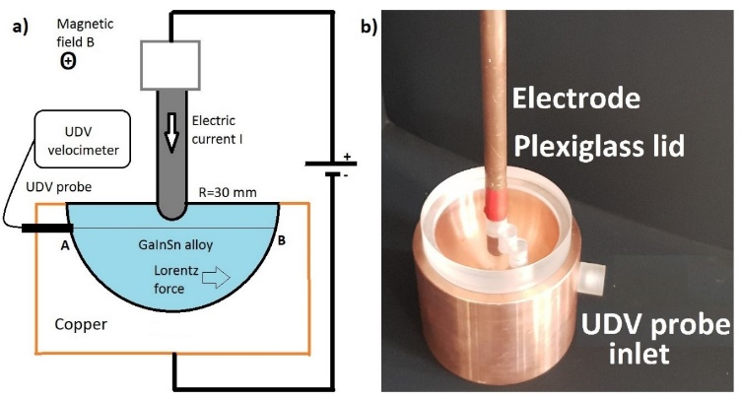

Figure 1: Experimental setup; a) principal scheme of the experiment; b) copper container and electrode used in model experiments.
(Times New Roman, 11 pt)

2. Equations should be numbered and centered; notations explained if needed.

, (1)

, (2)
where A stands for …, j is …. , etc.

3. Tables should have numbers and titles and should be centered.

Table 1: Comparison of characteristic dimensionless numbers
(Times New Roman, 11 pt)

Dimensionless number | GaInSn model | Welding | Physical explanation
$$Re$$ | 3300 | 3700 | Turbulent flow if Re>2000
$$Ha$$ | 120 | 10 | Electromagnetic/viscous
R_{m} | 0.006 | 0.005 | Advection/Diffusion

Conclusions

Acknowledgements. If needed!

References (Times New Roman, 11 pt)

- K.C. MILLS, B.J. KEENE, R.F. BROOKS and A. SHIRALI. Marangoni effects in welding. Phil. Trans. R. Soc. Lond., vol. 356 (1998), no. 3, pp. 25-34.
- V. BOJAREVICS, J. FRIBERGS, E.I. SHILOVA, E.V. SHCHERBININ. Electrically Induced Vortical Flows. (Kluwer Academic Publishers, Dordrecht, Boston, London, 1989).
- Yu. GELFGAT, S.M. GUREVICH, Ya. KOMPAN, E. MIKELSONS, K. NOVIKOV. Effect of magnetic field on the structure of welded joints in electrical slag welding of titanium alloys. Magnetohydrodynamics, vol. 2 (1973), no. 2, pp. 155-157.

